AUTO TICKET CLASSIFICATION USING FLOW DESIGNER : Project

By:

Aarthi.S - Team Leader Abinaya.M- Team Member
Abitha.P -Team Member
Afra Fathima.S-Team Member

University name: Alagappa university
College name: Madurai Sivakasi Nadars Pioneer Meenakshi Women's College
College code: Aluau13
Branch: Bachelor of Computer Applications
District: Sivagangai
Semester: 5

Auto Ticket Classification Using Flow Designer : Project

Introduction :

Automatic Ticket Classification using Flow Designer is a ServiceNow-based project designed to automate the process of classifying and managing tickets. When a user submits a ticket, the system automatically identifies the ticket category and assigns it to the appropriate team based on predefined conditions and rules. Flow Designer is used to create automated workflows without requiring extensive coding. This project reduces manual effort, minimizes classification errors, improves ticket handling speed, and helps organizations provide faster and more efficient IT support. It also improves productivity by ensuring that tickets reach the correct support team without unnecessary delays. Overall, this project enhances workflow efficiency and provides a better user experience through automated ticket management.

Project Objective:

The main objective of the Automatic Ticket Classification using Flow Designer project is to automate ticket classification and assignment in ServiceNow. This project aims to improve ticket management, reduce manual effort, and provide faster IT support.
- To automate the classification of tickets based on predefined conditions.
- To assign tickets automatically to the appropriate support teams.
- To reduce manual work and minimize classification errors.
- To improve the speed and efficiency of ticket processing.
- To use ServiceNow Flow Designer to create automated workflows.
- To reduce ticket assignment delays and improve response time.
- To enhance user satisfaction through efficient ticket management.

Milestone 1 : Flow Creation

Activity 1: Create a Flow to Create Catalog task to update the short description after Approval the service Request and it will be Assignment group to Hardware.
- Open service now.
- Click on All >> search for Flow Designer
- Click on Flow Designer under Process Automation.
- After opening Flow Designer Click on new and select Flow.
- Under Flow properties Give Flow Name as “ Standard laptop task”.
- Application should be Global.
- Select Run user as “ System user ” from that choice.
- Click on Submit.
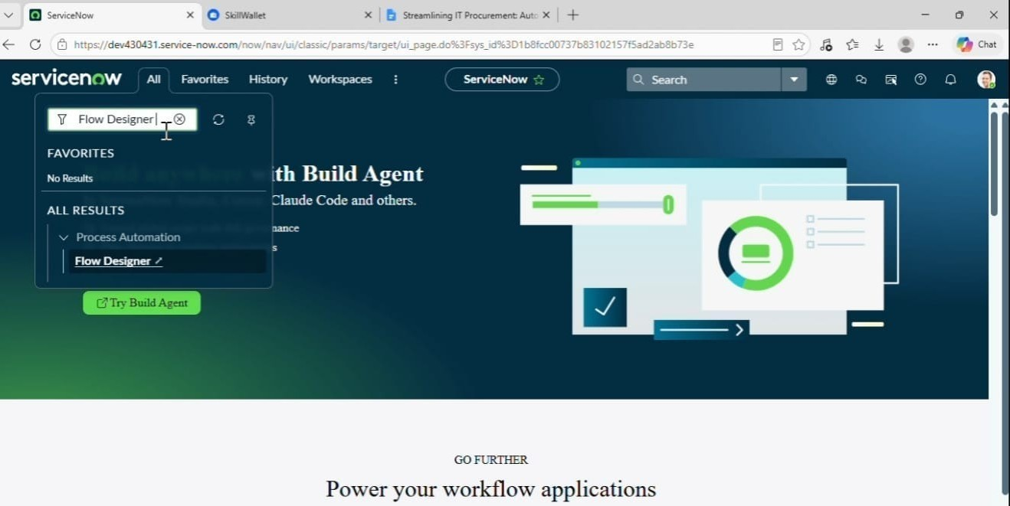
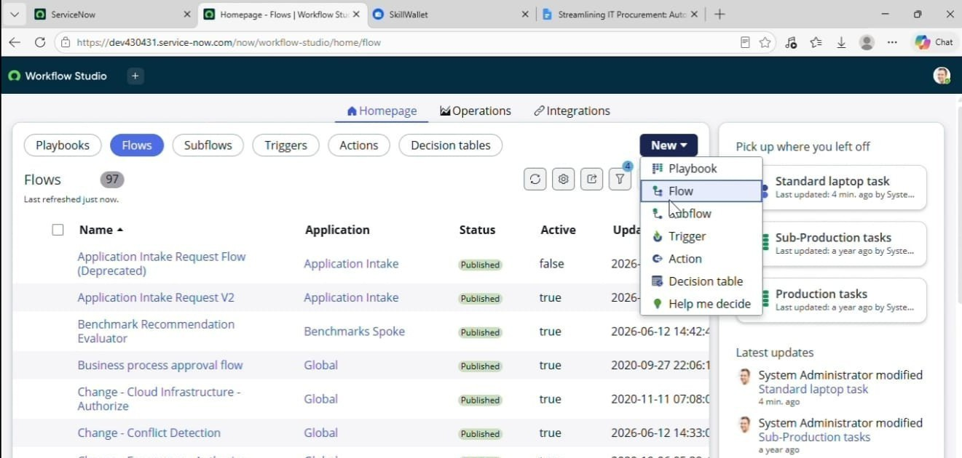

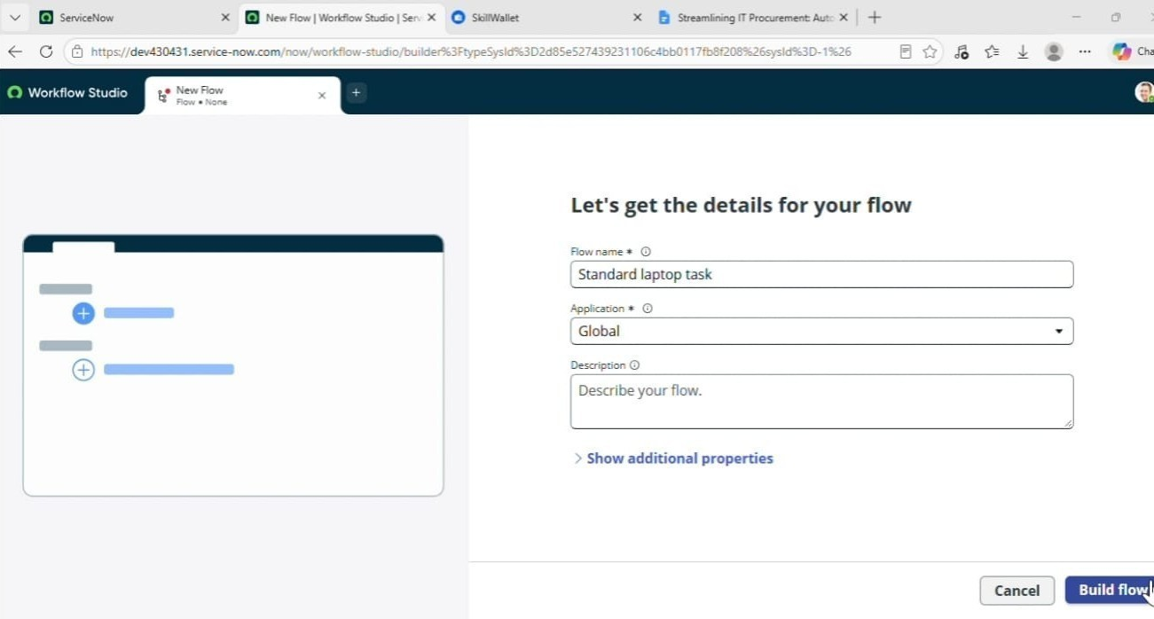
- Click on Add a trigger.
- Select the trigger in that Search for “ Service Catalog ” and select that.
- After that click on Done.
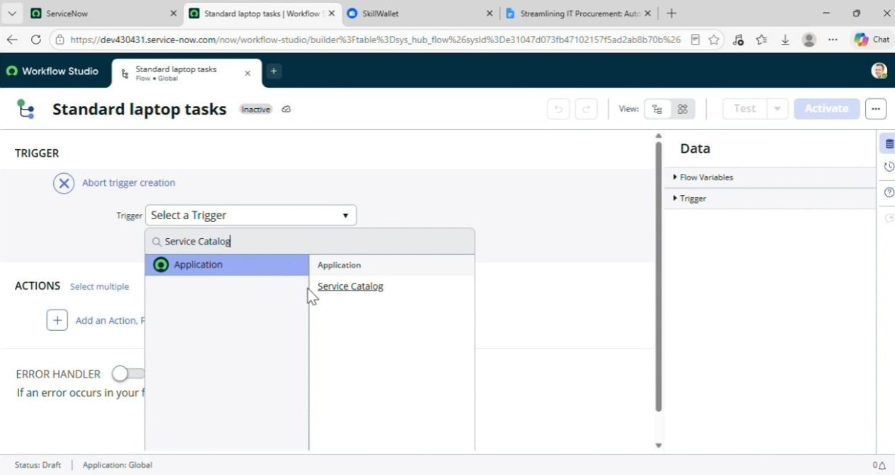

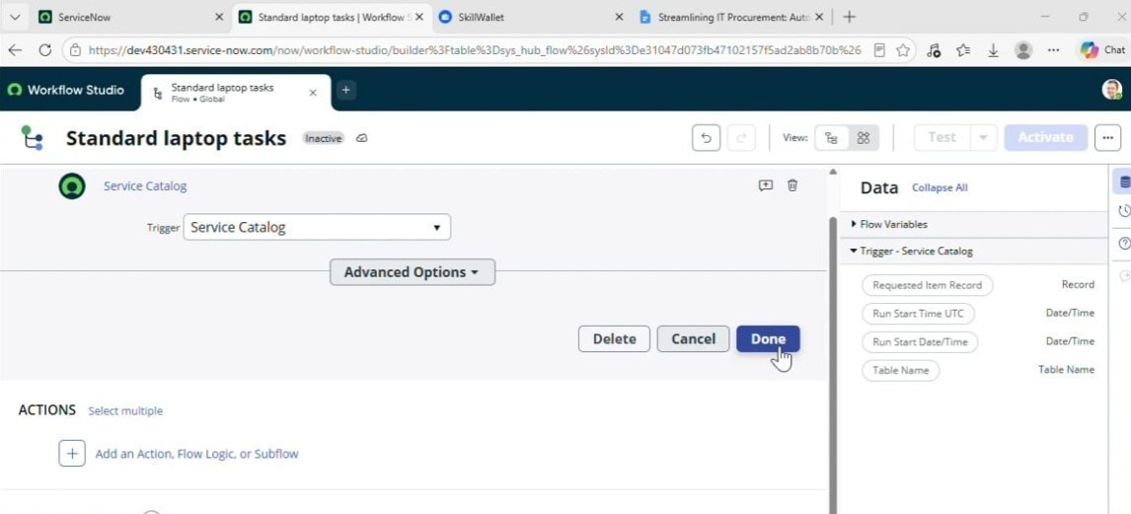
- Now under Actions.
- Click on Add an action.
- Select action in that search for “ Create Catalog Task ” and select that.
- Mention these in that action
- Action as Create Catalog Task
- Drag and drop the Requested Item Record in the Request item.

- Table will be auto populated as a Catalog Task.
- Mention the short description as “ Laptop need to Configured ”.
- Click on add field value
- Select description field and value as “ Laptop need to Configured ”.
- Select Assignment group field and value as “ Hardware ”.
- Select Approval field and value as “ Approved ”.
- Leave the remaining as default and click on Done.
- Click on save the Flow.
- And Click on Activate again click on Activate.
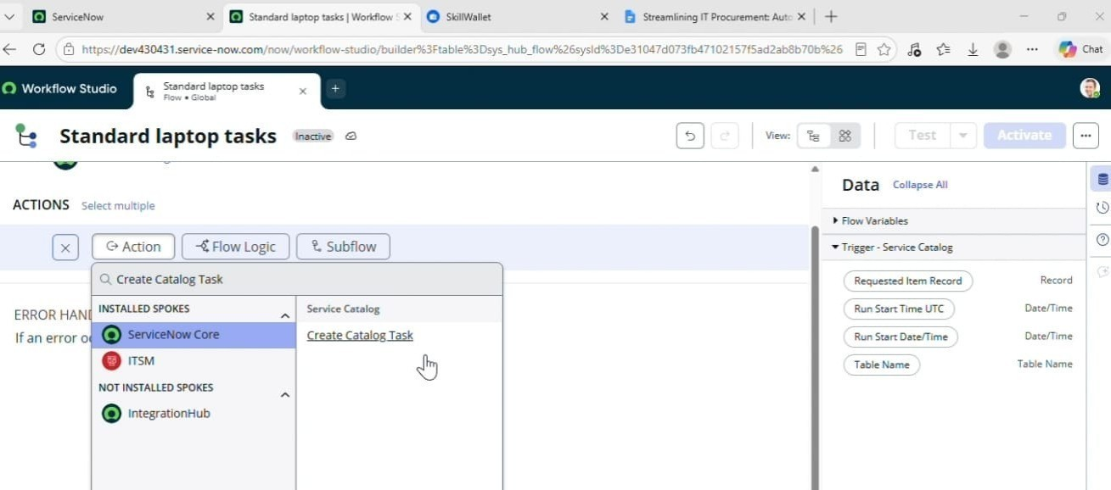

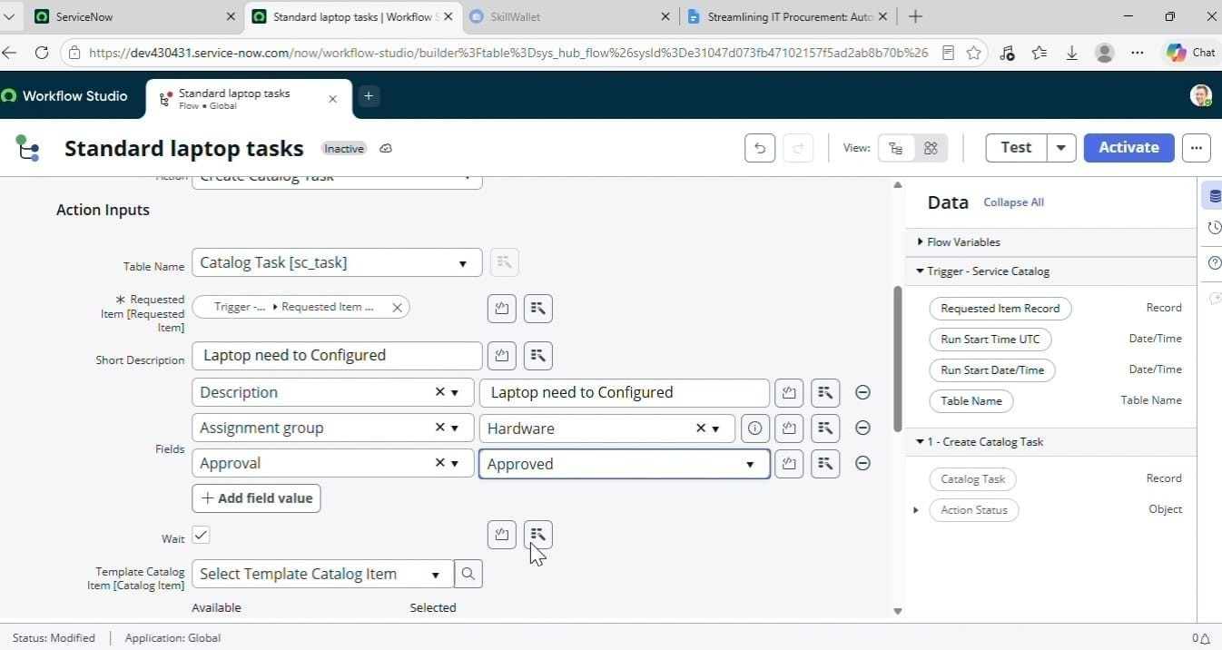

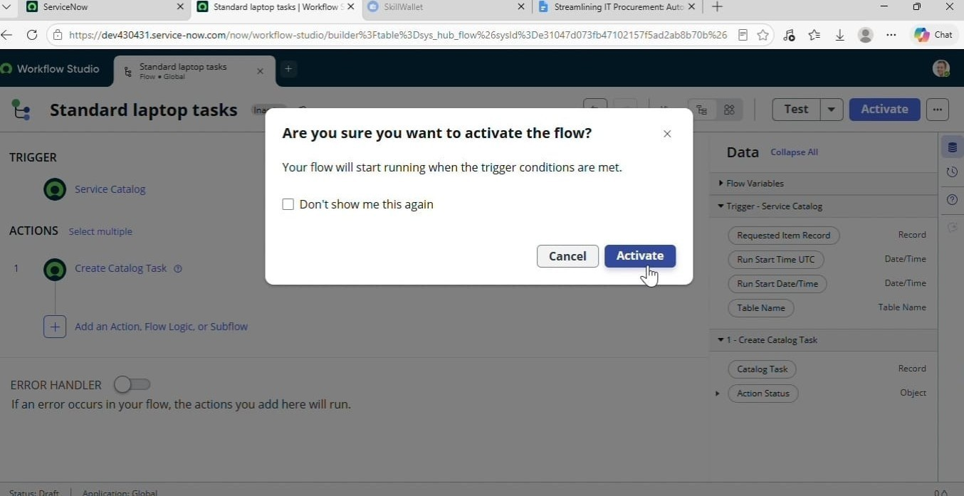

Milestone 2 : Flow assignment

Activity 1 : Flow Assignment to Standard laptop service Catalog.
- Open ServiceNow.
- Click on all search for Maintain Items.
- Select Maintain Items.
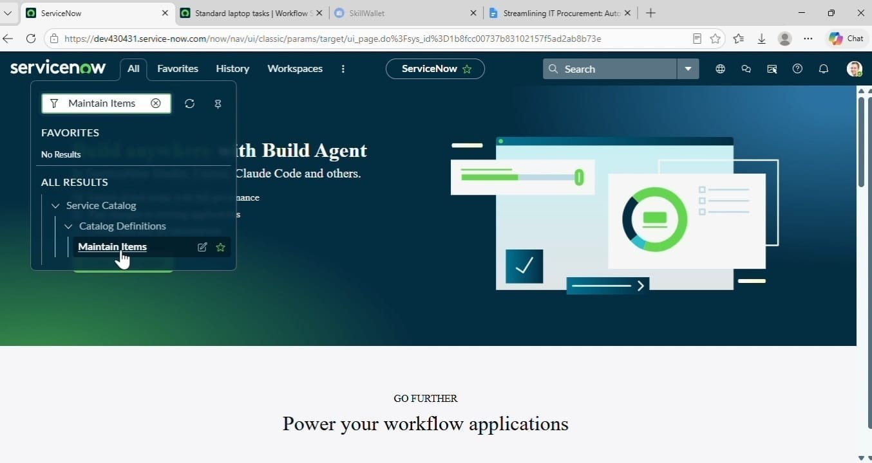
- Under the name field search for Standard Laptop Select that record.
- Under that record select Process engine
- Remove the remaining automations and add Flow.
- Add the flow that was created with the name “ Standard Laptop Task”.
- Click on the menu to save the record.

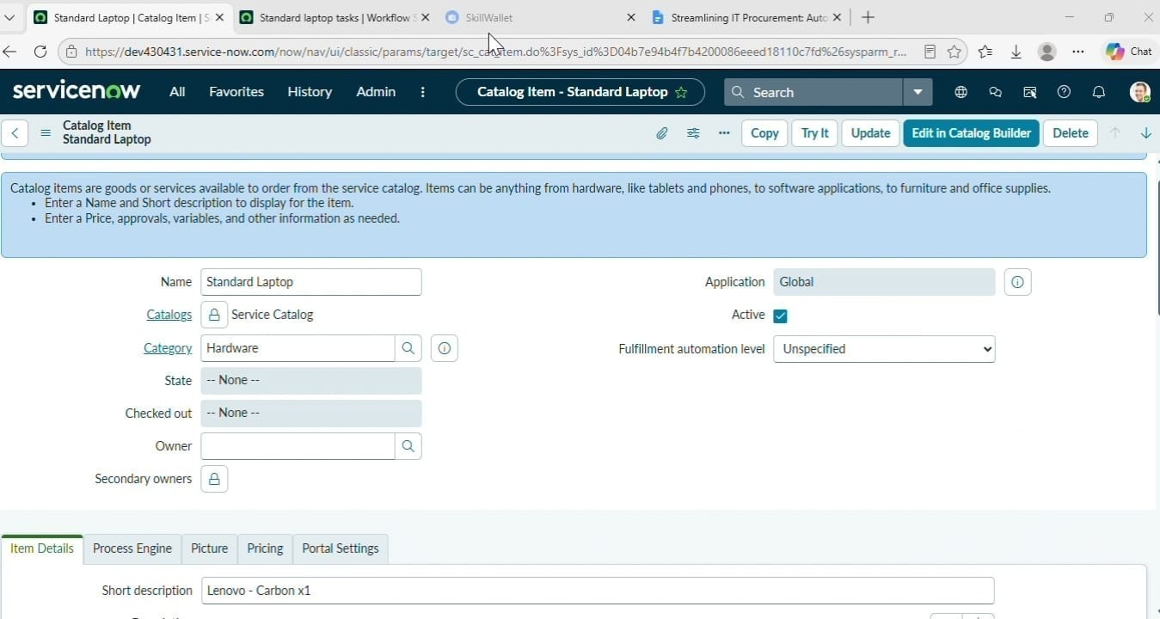

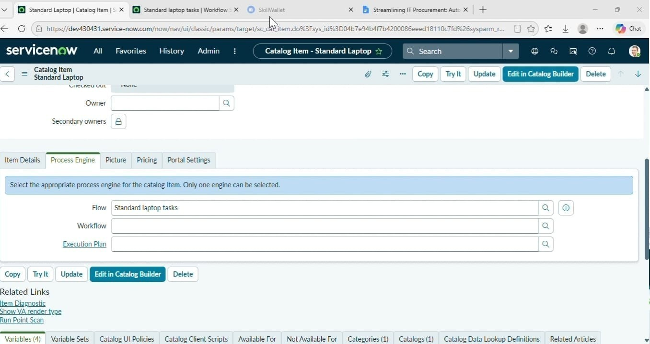

Milestone 3 : Service Catalog

Activity 1: Service Catalog for placing order and get Approval
- Click on All >> Search for “ Service Catalog ”.
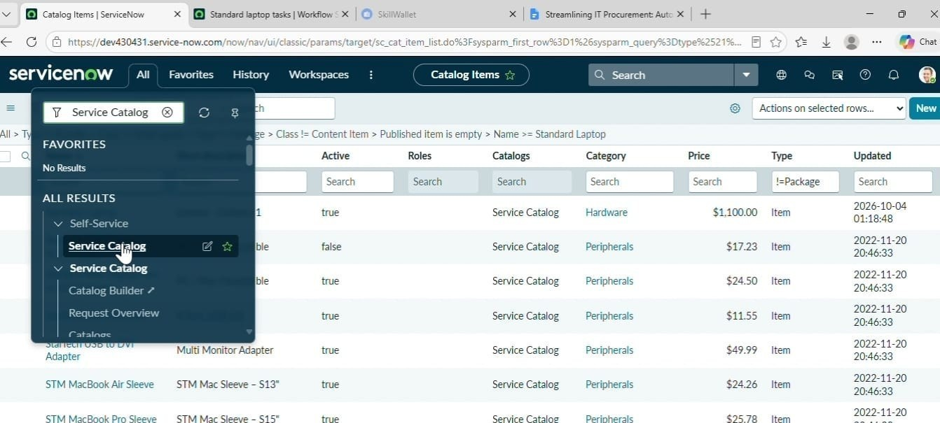

- Click on Service Catalog >> click on Hardware.
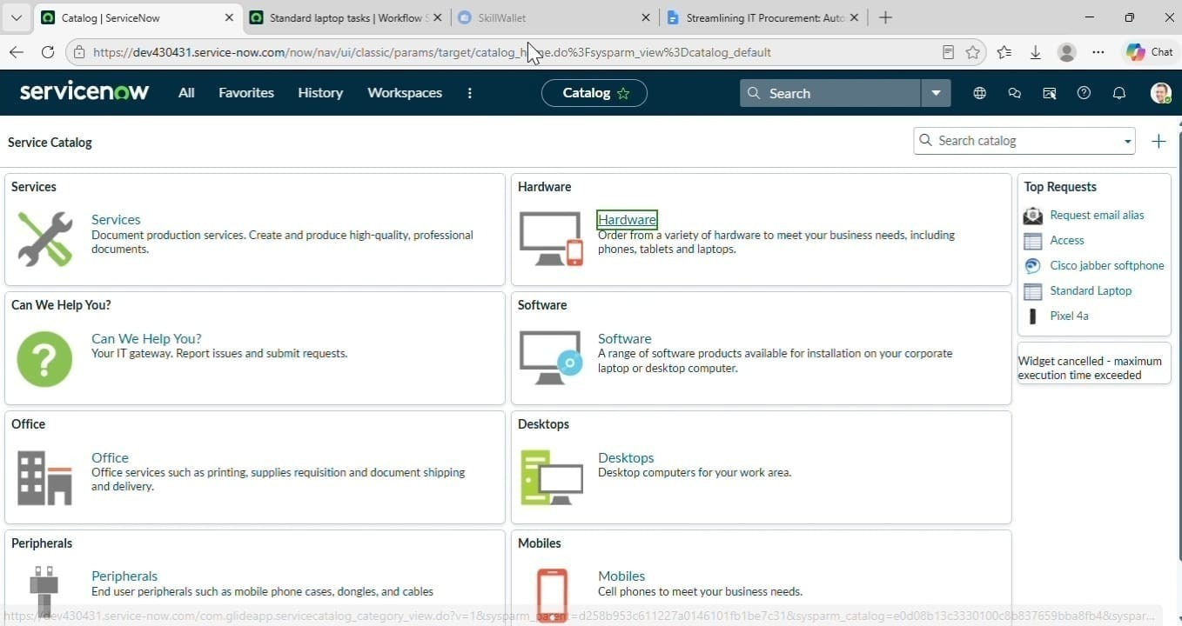

- Scroll a bit to find the “ Standard Laptop ” click on that.
- After that click on “ Order Now ” to place the request.
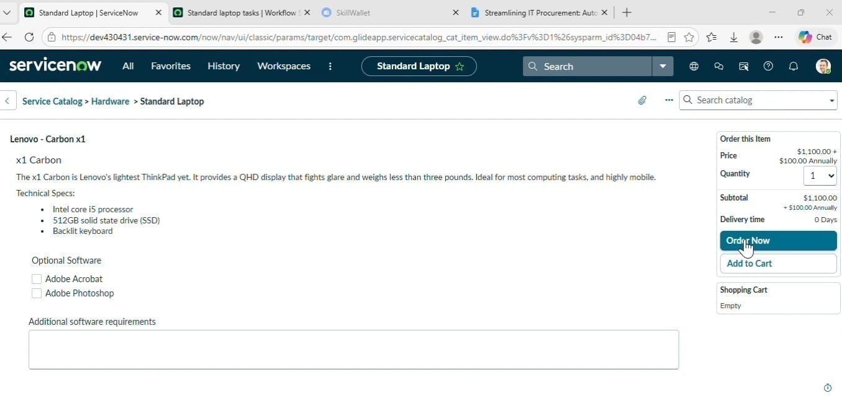

- Now we will see the Order status
- In that click on the Request Number
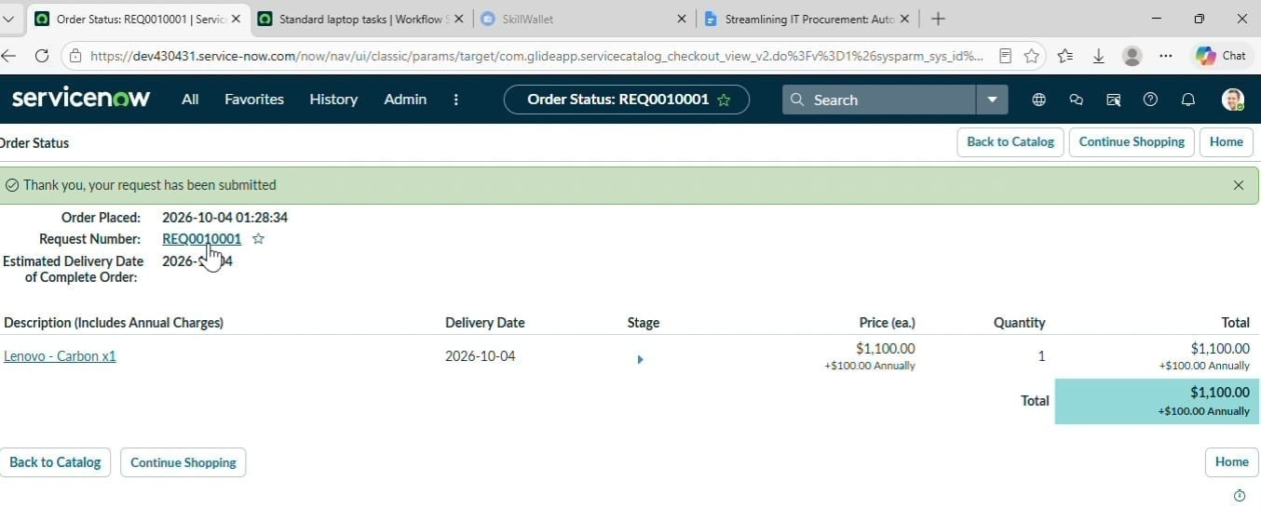

- It will open the Requested number record.
- Scroll down Click on the Approvers Section.
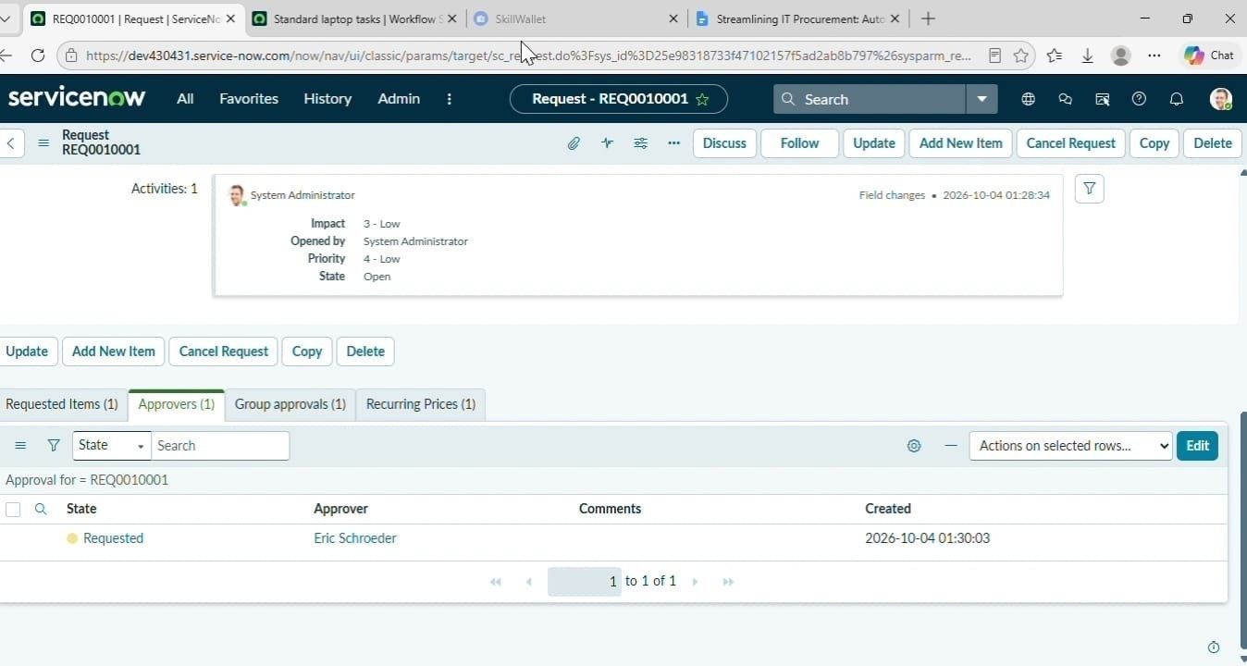

- Right Click on the Record to see config in that Click on the Approve.
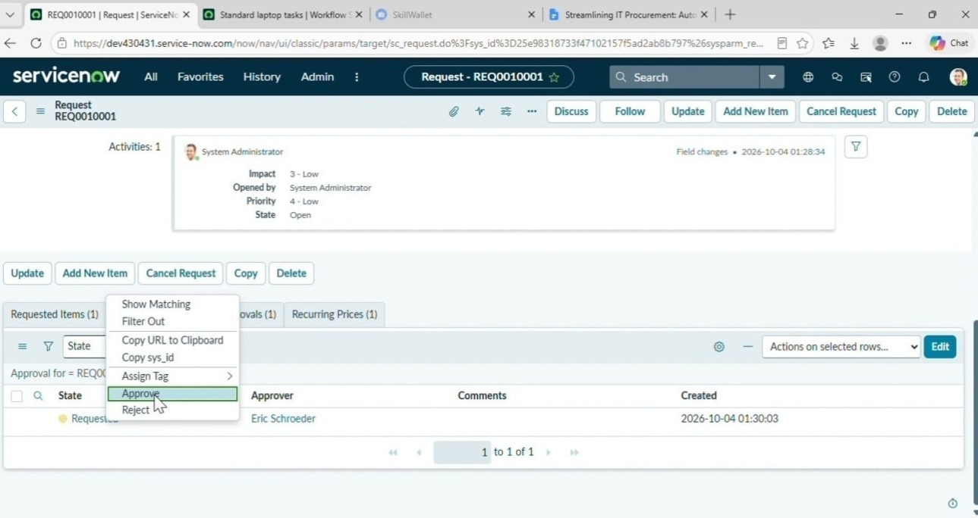

- Then click on the Requested item Section
- Open that Requested Item record
- Scroll down to the “ Catalog tasks ” Section
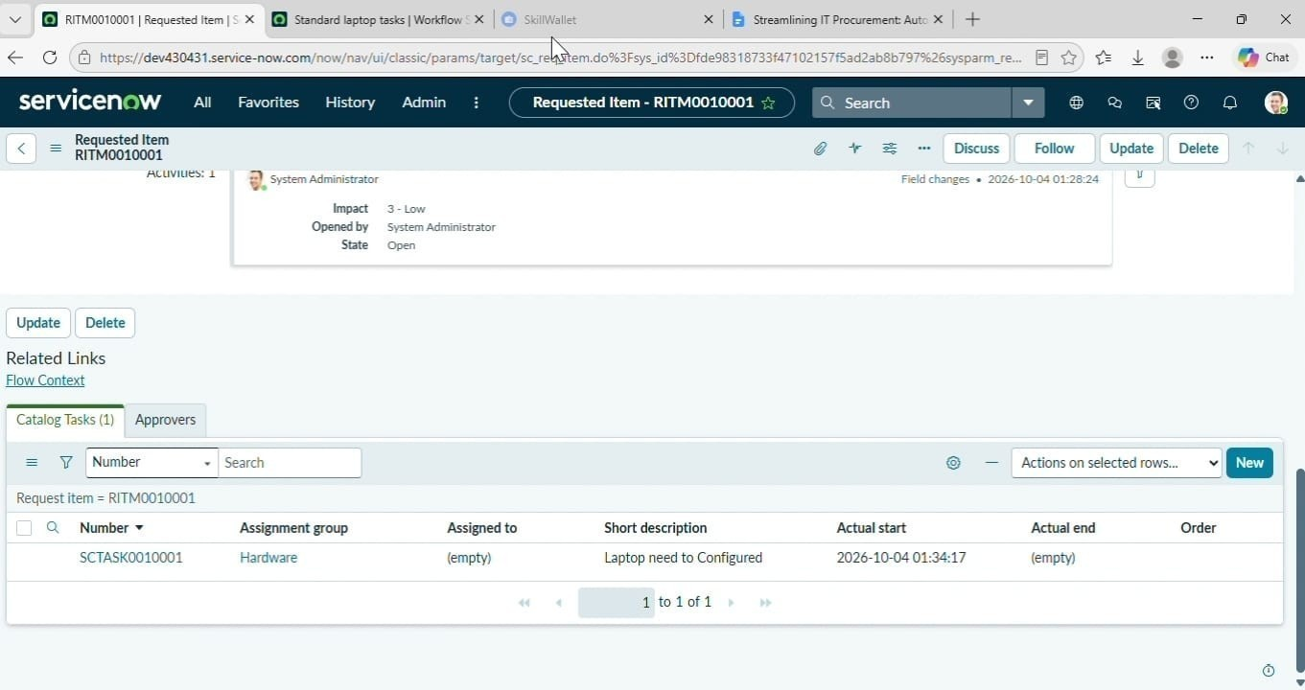
- Open the record to see the updated status of the record with Short description and Assigned group.
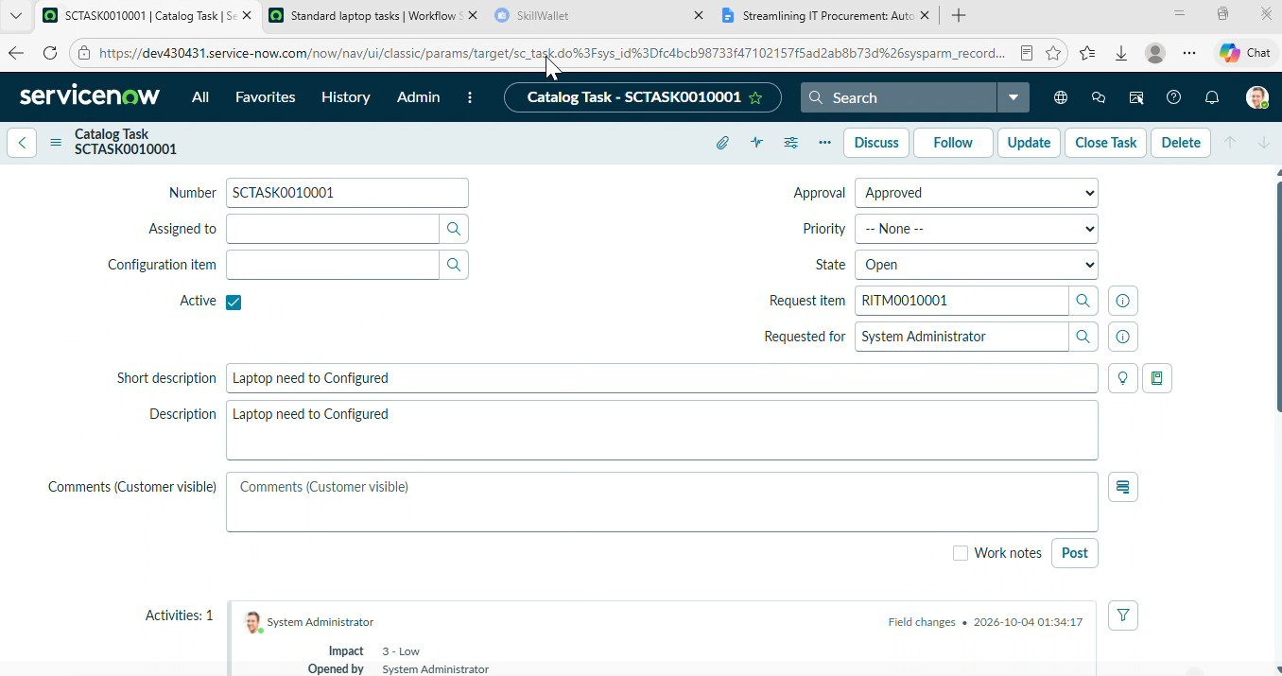

Conclusion :
The Automatic Ticket Classification using Flow Designer project successfully demonstrates the automation of ticket classification and assignment in ServiceNow. By using Flow Designer, tickets can be classified based on predefined conditions and assigned to the appropriate support teams automatically. This reduces manual effort, minimizes errors, and improves the efficiency of ticket management. The project also helps to reduce response time and enhance user satisfaction. Overall, this system provides a simple, reliable, and efficient solution for automating IT ticket management in an organization.

